**MA 3457 / CS 4033**

**Conference on 12/9**

In class, we have discussed explicit Euler method for the initial value problem y’=f(t,y) on a<t<b with initial condition y(a)=yo. We wish to approximate the solution y at a discrete time. Let wi+1 be the discrete approximation to the solution y at time at ti+1. These is the update rule when h= ti+1-ti

Explicit Euler: wi+1=wi+hf(ti,wi)

In the Monday lecture video, we learned that we can solve a system of first order initial value problems.

1. From 1a in 5.9 in Burden and Faires 9th edition:

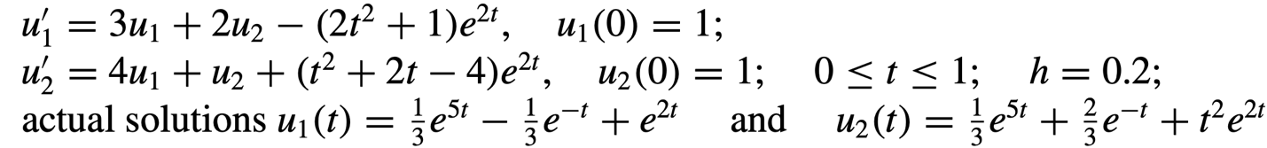

In class, we went over how to solve a boundary value problem by using our derivative approximations that were derived in Chapter 4. Here is a summary of those approximations for a function f:

2. Following the derivation in class, write a code to solve the following value problem:

c’’+c=0 for 0<x < $1$ where c(0)=1 and c’(1 $)$ =0

Here, we can compare our solution to the exact solution: c(x)=(exp(2-x)+exp(x))/(1+exp(2))